**Surah.e.furqan verses No#63 '64'65,66,71 Theme and translation**

**SURAT-UI-FURQAN**

This is the twenty fifth Surat of the "Holy Quran, and is included in the para (19) nineteenth. This surah is Makki. It has seventy seven ayats spread over in 6 ruku’. The last fifteen ayats are including in syllabus which describe the positive and negative qualities of the chosen and closely linked people of Allah. Lastly, it has the mention of the position chosen for them and their rank and also their rewards and requital in

the Hereafter.

Ayah 63-64

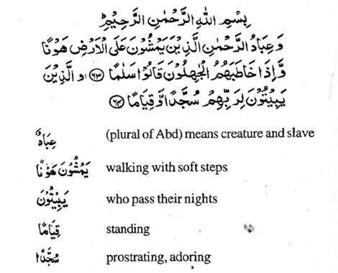

"The faithful slaves of the Beneficent Allah are those who walk upon the earth modestly, and when the ignorant people address them, they wish them peace, and who spend their rights prostrating and standing in prayer" 24In these ayahs, the routine life of the people chosen by Allah has been described, that they step on the Softly, which does not mean indecently, but walk with humility, civility, and modesty without Of pride or haughtiness, because Allah does not grant people, He has Himself said in the Qur'an

.

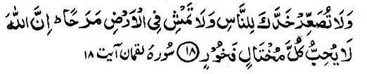

Undoubtedly. Allah does not like the strutting flaunting people. He further say

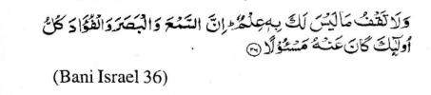

“And walk not on earth exultantly. Surely you cannot rend the earth,nor can you stretch high up to the length of the hill”. The second quality of those chosen people of Allah is that when they come across an ignorant person, who wants to entangle and pick up quarrels with them for nothing, stands in their way, and harass and disturb them without any real cause. These ignorant persons include those irreligious haughty persons, who are by nature inclined to tease those believers, who prefer to say good words to them and go away after salutation, instead of taking revenge more harshly,because they do not see any religious or worldly gain in courting any quarrel with such an ignorant person. To go away after salutation may have the implication of boycott and non-attachment. 25The seventh quality of these selected people has been described that instead of passing their nights in fun and pleasure or deep sleep, they spend their days and nights in the remembrance of Allah sacrificing peace and tranquility of their worldly life for the sake of eternal spiritual bliss and everlasting enjoyment of heart.

Ayahs 65-66

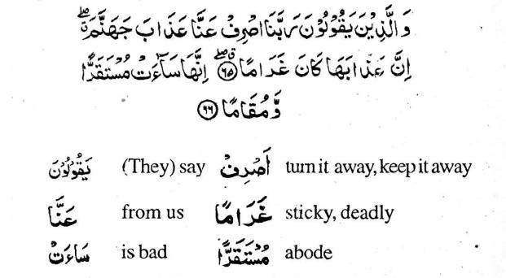

And who say:

Our Lord, avert from us the doom of hell. Such dooms are ever living. This (hell) is a bad place for abode and station." The fourth quality is that they do not take pride on their daily worships and adorations owing to their humility .It is for this reason that they take shelter in the Mercy of Allah from His wrath.

Ayat 67

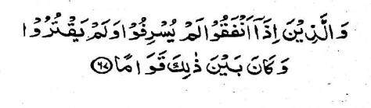

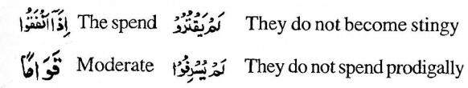

“And those who when spending, neither spend thrift o stingy, and theyare (rightly) between the two." The fifth quality of such persons is that these chosen people of Allah avoid to become stingy, or spendthrift just for show. The two word used in this ayat and have fold meanings, but it all shades of the meaning blended together, they give the quite opposite senses. Israf means spending too much for the purpose which

can be fulfilled with a lesser spending while the other word 'Iqtar’ means to spend too less in a very stingy and miserly, manner spending not where there is a genuine need of expenditure. But the third word Qawam means to take a course in between. This ayat particularly gives impetus to spend money as much as possible in the path of Allah, and to avoid untoward expenditure for unlawful and bad purposes. To spend for lawful causes and to avoid expenditure unlawfully is the real meaning of 'Iqtisad.'(اقتصاد)

Ayat 70-71

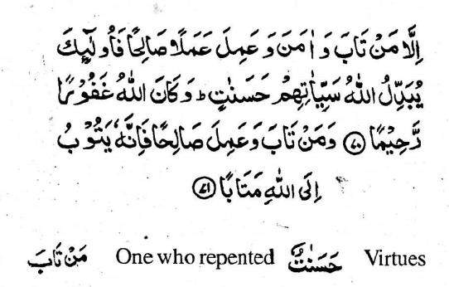

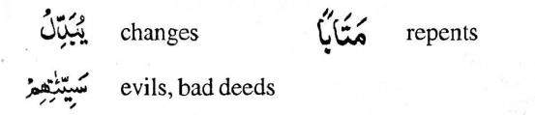

Except those who repent, and righteously work, Allah converts his evil deeds to good ones. Allah is forgiving, merciful. And whoever repents and does good work, decidedly he repents to Allah with good repentance".

In the above two ayats the ninth quality of the people Allah has been described and Allah. Sincere repentance to Allah i.e. Tauba, the literal meaning of which is to have a recourse to Quran-e-Majid has counted it among the attributes of human beings as well as the attribute of Allah. If Tauba refers to human beings, then its meaning would be to take a recourse to Allah for His Mercy, forgiveness and benevolence and to repent for his evil deeds, and if it refers to Allah, then it means attendance of Allah to the human beings with His mercy, forgiveness and benevolence and to accept the repentance of the people. To err 1s human. It is impossible for a human being not to err, and Islam has provided penitence only for this reason. And if a man commits a sin, he must not to lose heart, and live all his life pessimistically. It is for this reason that Allah has opened the road to hope to take a recourse to penitence. The true penitence which has been termed in Quran-e-Majid as Taubat-nn-Nasuh, (توبۃانصوح) makes the misdeeds of the fast also pardoned. There is a Hadith in this Connection

.



"A repentant sinner is like one who never committed any sin”.30 Even this ayat has brought a good tiding for repentant persons that Allah will change their sin in virtues. There are several ways in which this ayat has been interpreted by the scholars. First his sins will be forgiven and he will have the impetus of doing virtuous act in future. Secondly, it is not impossible for the Merciful Allah to delete all the sins from the character roll of repentant person and replace all those sinful acts by virtuous deeds. A Hadith throws some light on it. The Great Prophet (SAW) said, "A man will be produced on the Day of Judgment, and his minor sins will be asked to be produced. Thus, his; minor sins will be produced, and the major sins will he kept hidden. He will be asked about the commission of those minor sins, which he will admit, while the thought of major sins will make him overawed. Allah will then order to give one virtue against each sin. When he will have this odd observation of the mercy and beneficence of the Great Allah, he will call out that he had committed some more major sins which were not yet produced. Perhaps he was thinking that those would also be replaced by virtues. The traditionalist says that he saw the Great Prophet (SAW) became overjoyed at the time when he was narrating this story so much so that he smiled and his front teeth were observed by the audience.

There are a few stipulations about the acceptance of Tauba which have been underlined by the scholars, four of which are described as follows.

1) It is necessary that a sinner should open-heartedly admit of his sin and should be sincerely repentant on that.31

2) After this clear admission, he should ask the forgiveness of Allah for the commission of that sin.

3) If the sin has been committed in a hidden manner then he is allowed to ask Allah's forgiveness in seclusion but if he has committed sin openly, then it is necessary to implore Tauba openly.

4) If the sin has been committed in such a way that it has a concern with a person, then it is compulsory for him to beseech for the excuse of that person too and to make good the losses he had committed to that man, and if he has died, then his lawful heirs should he contacted. If the loss committed has any concern with rr1oney, then it is necessary to gift the same amount in charity, and if it relates to anything other

than money, it is sufficient to beg forgiveness of Allah.

**1#Qualities of Ibad-ur-Rehman**

x